
Insch Medical Practice

Dr Stephen J. Teale
Dr Karen Simpson
Dr Paul J. Davies
Dr Kate Irvine
Dr Alison Steen

Information Leaflet for Patients Suitable for Serial Prescriptions

1. Why are my repeat medications being considered for serial prescribing?
You have been identified as having a long term condition which requires medication. As your medication(s) is/are quite stable, and you regularly attend reviews, it has been decided by your GP that it is appropriate for you to have a long term prescription for these items.

2. What is a serial prescription?
A normal repeat prescription is set up for 8 issues by the GP. You contact the Practice each time you require another issue (Usually every 4 – 8 weeks) and request your medication. After 8 issues the GP will review your medication and all being well, will add another 8 issues to your file.
A serial prescription is issued by your GP for 24, 48 or 56 weeks. It will be issued at the same interval as your repeat prescription (usually 4 or 8 weeks) but you will not have to request the medication from the GP Practice. It will be dispensed by the Community Pharmacy (Chemist) when it is due, so it will be ready for you to collect before you run out of medication. This makes collecting prescriptions much easier for you and saves time at the GP Practice. You will not need to reorder the items on your serial prescription from the surgery or Chemist.

3. What happens when the serial prescription runs out?
When it runs out, an electronic message will be sent by the chemist to the GP Practice for it to be re-issued. If you have a chronic disease such as diabetes, asthma, COPD, etc and have attended your annual or twice annual review appointment then the serial prescription will be reviewed with the information from that review and all being well, reissued without you having to request it. If you fail to attend your review appointment then the serial prescription cannot be reissued and will return to normal repeat prescriptions where you will have to request your medication from the GP Practice every 4 – 8 weeks.

4. Can I use any Chemist?
You can use any Chemist for the duration of your serial prescription. Your first serial prescription will be sent to the Chemist that is recorded by your GP as being your ‘preferred pharmacy’. If you wish to use an alternative Chemist, contact your GP who will cancel the first prescription and re-issue it to the Chemist of your choice.
When your first serial prescription is set up, the Chemist will ask you to register with them and sign a form. They will then ask some questions about your medication and general health. You will need to collect your serial prescription items from the Chemist you are registered with. You can attend any Chemist for any other prescriptions or to buy medicine or seek advice. If you wish to change the Chemist you get your serial prescription from please inform both the Chemist and your GP Practice.

5. Is anything not covered by my serial prescription?
Some items that you only use occasionally such as creams and emollients will not be included on a serial prescription. These should continue to be ordered through the prescription line or online services. Please discuss with the Chemist where you collect your prescriptions any questions you have about what is not covered by your serial prescription.

6. What do I do if my medicines change?
If your medicines change the GP and Chemist will coordinate to ensure that any changes are made to your serial prescription. It is good practice to check your medicines before you leave the Chemist to ensure the prescription has been updated. This prevents waste to the NHS and allows the Chemist to organise a supply of any missing items. Not all new medicines that your GP prescribes will be added to the serial prescription. If it is short term or a medicine you are just starting on you will still need to order these items yourself until such time as the GP decides that it is appropriate to add to your serial prescription.

7. What do I do if I am going away on holiday?
Please let your Chemist know 1-2 weeks in advance when you will be away and how long for. This will enable them to have your prescription ready in time.

8. Who can I contact for more information?
Please speak to your Chemist if you have any further queries.

Yours sincerely,
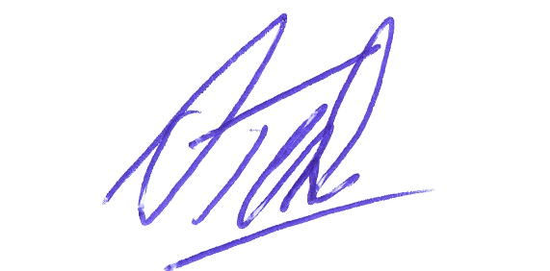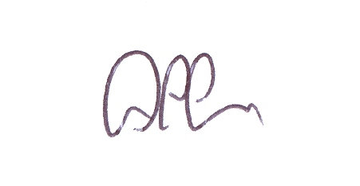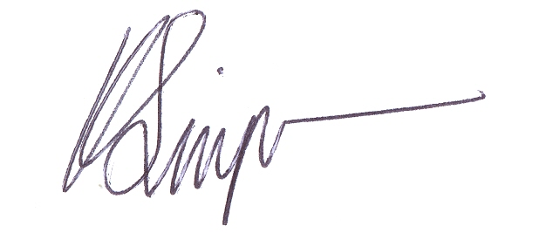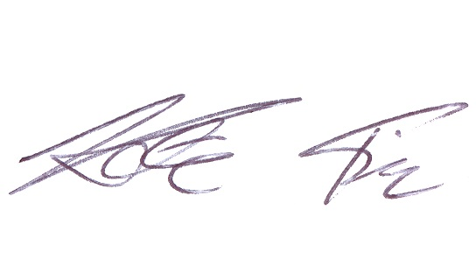

Dr SJTeale Dr PJ Davies Dr K Simpson Dr K Irvine Dr Alison Steen
GP Partner GP Partner GP Partner GP Partner GP Partner

